Ethical Hacking Lab
Unit 2 Footprinting and Reconnaissance:
Practical 2
Aim : Using the software tools/commands to perform the following , generate an analysis report :
- To perform footprinting using Google Hacking .

Basic Examples | Finds Pages Containing
biking Italy | The words biking and Italy
recycle steel OR Iron | Information on recycling steel or recycling iron
“I have a dream” | The extract phase I have a dream
Salsa –dance | The word salsa but not the word dance
Louis “I” France | Information about the Louis the First(I), weeding out the kings of France
castle ~glossary | Glosarries about caatles, as well as dictionary,list of terms,terminology etc
Fortune-telling | All forms of terms wether spelled as a single word, a phrase or hyphenated
Define: imbrogllo | Definations of the word Imbrogllo from the web

Calculator Operators | Meaning | Search Query
+ - * / | Basic arithmetic | 12+34-56*7/8
% of | Percentage of | 45 % of 39
^ or ** | Raise to a power | 2^5 or 2**5
Old units in new units | Convert units | 300 Euros in USD,  130 lbs in kg,  31 in hex

Restrict Search | Meaning | Search Query
City 1 City 2 | Book flights | sfo bos  mum blr
Site: | Search only one website or domain | Halloween alte :www.census.gov
[#] [#] | Search within a range of numbers | Dave Barry pirate 2002 2006
filetype: | Find documents of the specified type | form 1098 –T IRS filetype:pdf
Llnk | Find linked pages , show pages that point to url | llnk:warriorlibrarian.com

Specialized Information Queries | Meaning | Search Query
Book or books | Search full text of books | Book Ender’s Game
Define, what is, what are | Show a definition for a word or phrase | Define monopsony , what is podcast,
define: | Provide definations for a word , phrases and acronomy from the web | define: kerning
movie: | Find reviews and showtimes | movie: traffic  movie: taare zameen par
stocks: | Given ticker symbol,show stock information. | stocks: goog
weather | Given a location , show the weather | Weather Mumbai 400028

B. To find out the information about the a website
- To find out the information about the a website :
http://whois.domaintools.com
- Input your college website in the input box and display the information obtained.

C. To find the information about an archived website.
- To find the information about an archived website.
www.archive.org
- Display the snapshot of how the your college website looked like(Eg nmitd.edu.in) in the year 2013 on 23rd April.

D. To fetch DNS information.
- To fetch DNS information of www.indiana.edu and www.gmail.com. That is, find the IP addresses and Aliases of the above websites: Goto command prompt and perform the following:
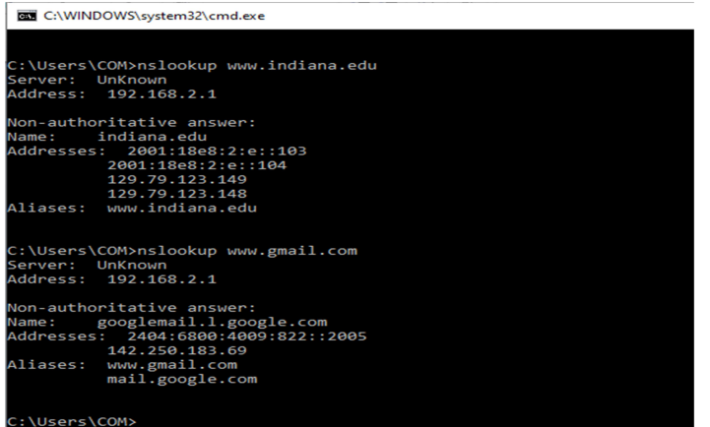

- Goto ping.eu on the site.
Locate DNS lookup and type the domain name to obtain the IP addresses and aliases
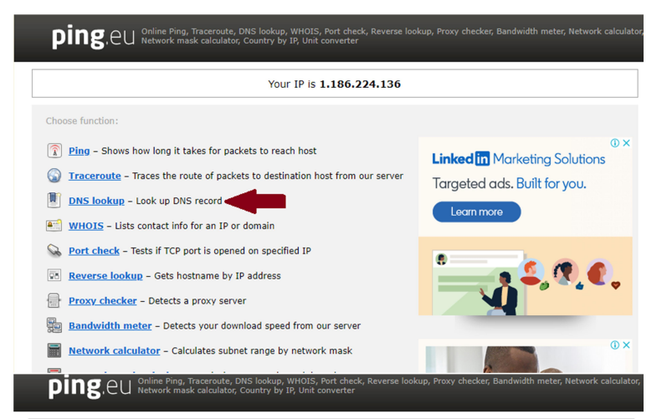

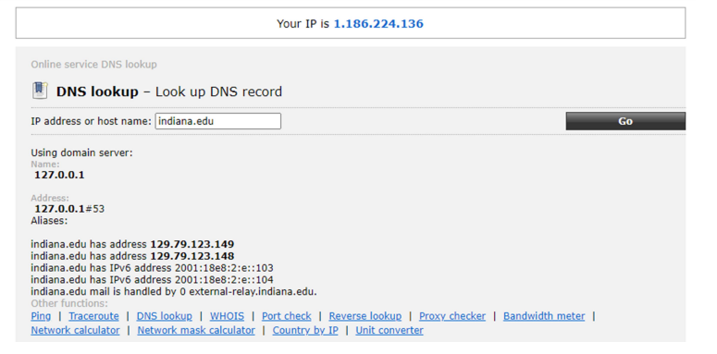
References:
https://www.oakton.edu/user/2/rjtaylor/cis101/Google%20Hacking%20101.pdf
http://www.googleguide.com/print/adv_op_ref.pdf

